PROJECT NAME:MARKET BASKET INSIGHTS

SUBMITTED BY: JABASTION GNANARAJ G

MAIL ID: **gjabastion@gmail.com**

**ABSTRACT:**

In the dynamic landscape of retail, understanding consumer behavior is paramount for businesses seeking to optimize sales strategies and enhance customer experiences. This abstract introduces a comprehensive study focused on market basket insights—a data-driven approach to unraveling the intricate web of consumer purchasing patterns.

Our research delves into the core concepts of market basket analysis, utilizing advanced data mining techniques to extract meaningful associations and trends from transactional data. By examining the contents of shoppers’ baskets and identifying frequently co-purchased items, we uncover valuable insights that empower retailers to make informed decisions regarding product placement, promotions, and inventory management.

Moreover, this study showcases the practical applications of market basket insights across various industries, from grocery stores to e-commerce platforms. We explore real-world case studies and success stories, highlighting how organizations have leveraged these insights to boost sales, personalize marketing campaigns, and enhance customer satisfaction.

As consumer preferences continue to evolve, the ability to harness market basket insights becomes increasingly essential for businesses to stay competitive and adapt to changing market dynamics. This research serves as a valuable resource for professionals and researchers in the field of retail analytics, offering a glimpse into the power of data-driven strategies in understanding and influencing consumer behavior.

**INTRODUCTION:**

Market basket insights, often hailed as the secret sauce of modern retail, offer a profound glimpse into consumer preferences and behavior. In a world where data reigns supreme, understanding what products customers purchase together can unlock a treasure trove of opportunities for businesses. From enhancing cross-selling strategies to improving inventory management, market basket insights are the compass guiding retailers toward greater profitability and customer satisfaction. This introduction lays the found.

Market basket insights, a cornerstone of modern retail analytics, unveil intricate consumer shopping patterns. In essence, it’s the art of deciphering what items shoppers tend to purchase together during a single shopping trip. This seemingly mundane data can be a goldmine of strategic information for businesses. By understanding these associations, companies can optimize their operations, boost sales, and enhance the overall customer experience.

In today’s hyper-competitive market, where consumers have a plethora of choices, market basket insights are invaluable. They empower retailers to fine-tune their marketing strategies, optimize product placements, and tailor promotions. Moreover, these insights are a potent tool for inventory management, helping businesses minimize wastage and ensure products are in stock when customers want them.

This introduction sets the stage for a deeper exploration of the multifaceted world of market basket insights. From uncovering hidden correlations to shaping personalized recommendations, we’ll journey through the vast landscape of data-driven retail optimization. Join us as we delve into the fascinating realm of market basket insights and discover how they’re reshaping the way businesses understand and cater to consumer needs.

**Problem Definition:**

Market basket insights aim to uncover associations and patterns in customer transaction data to understand the co-occurrence of items in a shopping cart. Specifically, it involves:

**Data Collection:**

Gathering transaction data, typically from point-of-sale systems or e-commerce platforms, including information about items purchased in each transaction.

**Association Rule Mining:**

Applying data mining techniques, such as or FP-Growth, to discover associations or rules that indicate which items tend to be bought together. These rules often consist of antecedents (items in the basket) and consequents (items that also appear).

**Support, Confidence, and Lift:**

Evaluating the strength of these associations using metrics like support (the frequency of occurrence), confidence (the likelihood of the consequent item being purchased given the antecedent), and lift (how much the purchase of the antecedent item affects the purchase of the consequent item).

**Insights Generation:**

Drawing actionable insights from the discovered associations. For example, identifying which items are frequently purchased together can inform marketing strategies, stock placement, or product bundling.

**Business Applications**

: Applying these insights to improve business operations, such as optimizing product placement in physical stores, creating targeted marketing campaigns, or suggesting related products online to increase sales and customer satisfaction.

**OBJECTIVES:**

**Increase Cross-Selling:**

Identify product combinations frequently purchased together to optimize cross-selling and increase average transaction value.

**Inventory Management:**

Improve stock management by recognizing which items are commonly bought together, reducing overstock or out-of-stock situations.

**Promotion Optimization:**

Determine which products should be promoted together to maximize the impact of marketing campaigns and discounts.

**Customer Segmentation:**

Segment customers based on their purchasing patterns to target them with personalized offers and recommendations.

**Store Layout and Design**:

Use insights to optimize store layout, placing related items closer to each other to encourage additional purchases.

**Supply Chain Efficiency:**

Streamline the supply chain by aligning production and distribution with popular product combinations.

**Price Strategy:**

Adjust pricing strategies based on how items are bundled together in customer transactions.

**Loss Prevention:**

Detect and prevent fraud or theft by identifying unusual purchasing patterns.

**Seasonal Trends:**

Understand how customer preferences change with seasons or holidays to plan for inventory and promotions accordingly.

**Customer Experience:**

Enhance the overall shopping experience by tailoring product recommendations and product placements.

**Data Collection:**

Gather transactional data from your sales records, including customer IDs, product IDs, and purchase timestamps.

Store the data securely in a database or data warehouse.

**Data Preprocessing:**

Clean and preprocess the data to handle missing values, outliers, and inconsistencies.

Transform the data into a format suitable for analysis.

**Market Basket Analysis:**

Use association rule mining techniques like or FP-Growth to identify patterns and associations between products frequently bought together.

Calculate metrics like support, confidence, and lift to quantify the significance of these associations.

**Customer Segmentation:**

Cluster customers based on their purchase behavior or demographics.

Identify segments with distinct shopping patterns.

**Visualizations and Reports:**

Create visualizations such as scatter plots, and bar charts to present the insights.

Generate regular reports or dashboard

**Reduce Churn:**

Prevent customer attrition by offering personalized incentives.

**Increase Revenue:**

Maximize revenue by capitalizing on purchasing patterns.

**DESIGN:**

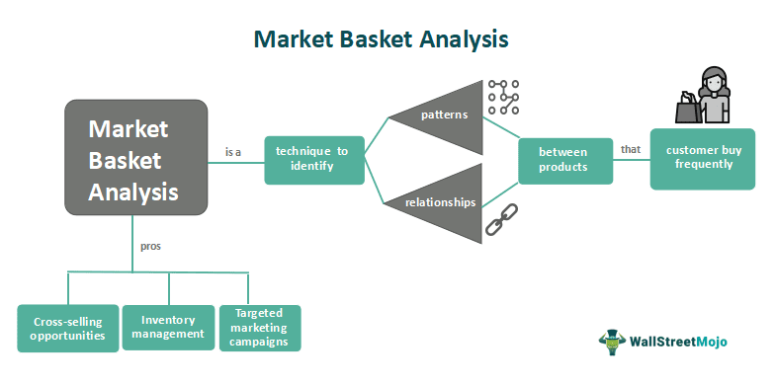

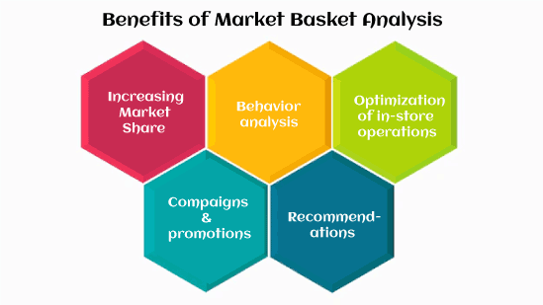

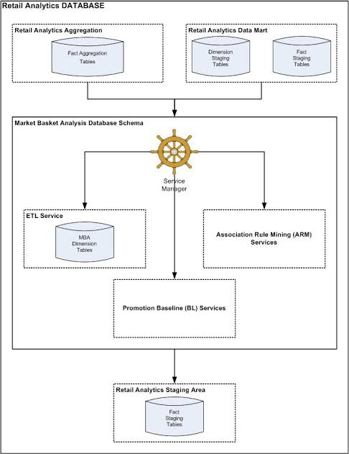

**INNOVATION TO SOLVE THE PROBLEM IN DESIGN**

Innovations for market basket insights involves creating new approaches or tools to customer shopping behaviour and extract valuable insights.

**Data Gathering:**

Collect data from various sources like POS systems, e-commerce platforms, and customer surveys.

**Ethical Compliance:**

Adhere to data privacy regulations and ethical considerations.

**Feedback Loop:**

Continuously improve the system based on user feedback and changing market dynamics.

**Business Impact Metrics:**

Define KPIs to measure the system’s impact on sales, customer satisfaction, and profitability.

**Block chain for Transparency:**

Utilize block chain technology to enhance transparency in the supply chain, allowing customers to trace the origin and journey of products, thereby building trust.

**Voice Commerce:**

Integrate voice-activated shopping experiences, like voice assistants and smart speakers, to enable customers to make purchases using natural language.

**Augmented Reality (AR):**

Create AR applications that allow customers to virtually try products before purchase, enhancing their shopping experience and reducing return rates.

**Subscription-Based Models:**

Explore innovative subscription models that offer curated product bundles or access to exclusive deals, increasing customer loyalty.

**Sustainability Insights:**

Provide insights into the environmental impact of products, helping eco-conscious customers make informed choices.

**Behavioural Biometrics:**

Use biometric data for identity verification in e-commerce, enhancing security while streamlining the checkout process.

**Zero-Click Shopping:**

Develop solutions that enable customers to make purchases with minimal effort, such as automatic reorders based on past preferences.

**CHANGES IN DESIGN**

**Data Collection and Storage:**

Improve Data Sources: Explore additional sources of data, such as customer reviews, social media, or external market data, to enrich your analysis.

**Cloud-Based Storage:**

Consider moving to cloud-based storage solutions for scalability and easier data management.

**Data Pre processing:**

Advanced Data Cleaning: Implement more advanced techniques like natural language processing (NLP) for text data or outlier detection methods to enhance data quality.

**Algorithm Selection:**

Machine Learning Integration: Incorporate machine learning models for more advanced pattern recognition and predictive analytics.

**Visualization and Reporting:**

Interactive Dashboards: Build interactive dashboards that allow stakeholders to explore insights in real-time.

**Predictive Visualizations:**

Use data visualization techniques to forecast future trends and customer source

**Privacy and Security:**

Differential Privacy: Implement differential privacy techniques to protect customer privacy while still extracting meaningful insights.

**Secure Data Sharing:**

Explore secure data-sharing protocols if you need to collaborate with other organizations.

**Real-time Analysis:**

Stream Processing: Implement stream processing for real-time market basket analysis, allowing you to respond to trends as they occur.

**Recommendation Engines:**

Develop recommendation engines based on customer preferences and marketing

**Customer Segmentation:**

Use clustering algorithms to segment customers for more targeted marketing.

**A/B Testing:**

Incorporate A/B testing methodologies to rigorously evaluate the impact of changes and recommendations.

**Feedback Loops:**

Customer Feedback Integration: Collect and incorporate customer feedback to refine recommendations and strategies continuously.

**Resource Allocation:**

Optimize Resource Usage: Allocate resources efficiently based on the priority and potential impact of different insights and recommendations.

**Collaboration:**

Cross-functional Teams: Foster collaboration between data scientists, marketers, and operations teams to ensure alignment between insights and actions.

**Documentation and Governance:**

Comprehensive Documentation: Maintain thorough documentation of data sources, processes, and models to ensure transparency and reproducibility.

**Ethical Considerations:**

Ethical Review Board: Establish an internal or external review board to ensure ethical data usage and adherence to best practices.

**BLOCKS TO BE ADDED**

**Data Quality Assurance:**

Data Cleaning: Develop robust data cleaning procedures to handle missing values, duplicates, and inconsistencies.

Data Validation: Regularly validate data integrity and correctness.

**Scalability:**

Distributed Computing: Consider using distributed computing frameworks like Hadoop or Spark for handling large datasets efficiently.

Sampling: When applicable, work with data samples for initial analysis and scale up as needed.

**Privacy Protection:**

Anonymization: Anonymize customer data to protect privacy while still allowing for analysis.

Compliance: Ensure strict compliance with data privacy regulations like GDPR.

**Sparse Data Handling:**

Explore Techniques: Use advanced techniques like matrix factorization or collaborative filtering to discover patterns in sparse data.

**Seasonality:**

Seasonal Adjustments: Apply seasonal adjustments or time series analysis to account for seasonal variations.

**Continuous Monitoring:**

Real-time Analytics: Implement real-time monitoring to adapt to changing trends promptly.

Regular Updates: Periodically update your model and recommendations to reflect evolving customer preferences.

Complex Retail Environment:

Multivariate Analysis: Incorporate additional factors like pricing, location, and demographics into your analysis to provide more comprehensive insights.

**Algorithm Selection:**

Experimentation: Experiment with different association rule mining algorithms and parameters to find the most suitable approach.

**Action Ability:**

Collaborative Approach: Involve domain experts, marketing teams, and decision-makers to translate insights into actionable strategies.

Pilot Testing: Test recommendations on a small scale before full-scale implementation.

**Competitive Intelligence:**

Data Aggregation: Aggregate data from multiple retailers in a way that preserves anonymity and avoids sharing sensitive information.

**Resource Allocation:**

Prioritization: Focus on the most impactful recommendations that align with available resources.

h **HNFBLOCKS TO ADD IN MARKET BASKET INSIGHTS**

**DATA ASSURANCE QUALITY**

**SCALABILITY**

**PRIVACY PROTECTION SEASONALITY**

**SPARCE DATA HANDLING ACTINOBILITY**

**COMPETITIVE**

**CONTINUOS MONITORING INTELLIGENCE**

**ALGORITHM SELECTION RESOURCE**

**ALLOCATION**

**MARKET BASKET ANALYSIS:**

Market Basket Analysis (MBA) is a valuable data mining technique that offers actionable insights for various industries, particularly in the retail sector. It helps businesses understand customer purchasing behavior and discover associations between products. By identifying which items are frequently purchased together, businesses can make informed decisions regarding product recommendations, store layouts, marketing strategies, and more

**DATA PREPARATION**:

Collect transaction data: You need a dataset containing information about customer transactions. Each row represents a transaction, and the columns represent items/products purchased.

**DATA PREPROCESSING**:

Encode the data: Transform the data into a suitable format for analysis, often using a one-hot encoding. This means creating binary variables for each product where 1 indicates the presence of the product in the transaction, and 0 indicates absence.

**FREQUENT ITEMSET MINING:**

Apriori Algorithm: The Apriori algorithm is commonly used for finding frequent itemsets. It works by generating candidate itemsets and pruning those that do not meet the specified minimum support threshold (a measure of how frequently an itemset appears in the dataset).

**ASSOCIATION RULE GENERATION:**

From the frequent itemsets, association rules are generated. These rules consist of an antecedent (items on the left) and a consequent (items on the right) with a certain confidence and support level.

**RULE PRUNING AND EVALUATION:**

Prune rules: Remove rules that do not meet certain criteria, such as minimum confidence and lift.

Evaluate rules: Assess the strength and significance of the remaining rules using measures like support, confidence, and lift.

**3.1BEGIN BUILDING YOUR MARKET BASKET ANALYSIS PROJECT:**

**LOADING A DATASET:**

**INSTALL KAGGLE API:**

If you haven't already, you need to install the Kaggle API package. You can do this using pip:

**pip install kaggle**

**GET KAGGLE API CREDENTIALS:**

You need a Kaggle account and a Kaggle API token to access datasets. You can get your API token by following these steps:

Go to your Kaggle account settings on the Kaggle website.

Scroll down to the "API" section and click on "Create New API Token."

This will download a JSON file containing your Kaggle API credentials.

Upload Kaggle API Credentials:

You need to upload your Kaggle API credentials JSON file to your working directory.

Now, you can use the Kaggle API to download the dataset from Kaggle and load it into your project.

How to load a dataset from Kaggle into your Python environment and begin building your Market Basket Analysis project. To load a dataset from Kaggle, you typically use the Kaggle API. Here's a step-by-step guide on how to do this:

**PYTHON CODE FOR LOAD THE DATA:**

import pandas as pd

from kaggle.api.kaggle_api_extended import KaggleApi

from zipfile import ZipFile

# Set your Kaggle API credentials

api = KaggleApi()

api.authenticate(api_key="your_api_key_here") # Replace with your API key

# Download the dataset

dataset_name = "aslanahmedov/market-basket-analysis"

api.dataset_download_files(dataset_name)

# Unzip the downloaded file

with ZipFile(f"{dataset_name}.zip", "r") as zip_ref:

zip_ref.extractall("data") # Extract the contents to a "data" directory

# Load the dataset into a DataFrame

df = pd.read_csv("data/your_dataset_filename.csv") # Replace with the actual CSV file name

Make sure to replace "your_api_key_here" with your actual Kaggle API key and "your_dataset_filename.csv" with the appropriate CSV file from the dataset.

Now you have loaded the dataset, and you can proceed with the steps mentioned earlier to perform Market Basket Analysis on it.

**3.2PREPROCESSING A DATASET:**

**LOAD THE DATASET:**

As mentioned earlier, you can load the dataset from Kaggle using the Kaggle API or by manually downloading it and loading it into your project.

**EXPLORE THE DATA:**

Start by examining the dataset to understand its structure, the columns it contains, and the nature of the data.

**HANDLE MISSING VALUES:**

Check for missing values in the dataset. Depending on the dataset and the library you're using, you can either drop rows with missing values or impute them with suitable values.

**DATA ENCODING:**

Market Basket Analysis typically requires transaction data in a specific format, often referred to as "basket data." Each row represents a transaction, and the columns represent items. Encode the data into this format, where each cell contains a binary value (1 if the item is present in the transaction, 0 if it's not).

**DATA TRANSFORMATION:**

Perform any additional data transformations as needed. This could include aggregating data, filtering out low-support items, or adjusting the dataset's structure to meet the Apriori algorithm's requirements.

**DATA MINING:**

Apply the Apriori algorithm or other frequent itemset mining techniques to find frequent itemsets in your dataset. These frequent itemsets are the foundation for generating association rules.

**GENERATE ASSOCIATION RULES:**

From the frequent itemsets, generate association rules using metrics such as support, confidence, and lift.

**Python code snippet for preprocessing a Market Basket Analysis dataset:**

import pandas as pd

from mlxtend.frequent_patterns import apriori

from mlxtend.frequent_patterns import association_rules

# Load the dataset

df = pd.read_csv("your_dataset.csv")

# Perform one-hot encoding

basket = pd.get_dummies(df, columns=["item_column"], prefix="", prefix_sep="")

# Group by transaction and sum the one-hot encoded items

basket = basket.groupby("transaction_id").sum()

# Convert item counts to 1 or 0

basket[basket >= 1] = 1

# Find frequent itemsets

frequent_itemsets = apriori(basket, min_support=0.1, use_colnames=True)

# Generate association rules

rules = association_rules(frequent_itemsets, metric="lift", min_threshold=1.0)

# Print the rules

print(rules)

Replace "your_dataset.csv" with the name of your dataset file and adjust the column names accordingly.

The code above demonstrates the preprocessing and analysis of a Market Basket Analysis dataset using the Apriori algorithm. Depending on your dataset's specifics, you may need to adapt these steps to your data.

**3.3ANALYSIS PROCESS:**

**FREQUENT ITEMSET ANALYSIS:**

Find frequent itemsets in the data, i.e., sets of items that are frequently purchased together.

Determine support values to identify how frequently these itemsets occur in the dataset.

**ASSOCIATION RULE ANALYSIS:**

Generate association rules that reveal the relationships between items.

Use metrics like confidence and lift to assess the strength and significance of these associations.

**ITEM SET SIZE ANALYSIS:**

Analyze the size (number of items) of frequent itemsets. Are customers more likely to buy small sets of items, or do they purchase larger sets?

**SUPPORT ANALYSIS:**

Explore the distribution of support values for different items or itemsets.

Identify items with high support to understand popular products.

**CONFIDENCE ANALYSIS:**

Examine confidence values for association rules.

Identify strong associations and potentially suggest cross-selling opportunities.

**LIFT ANALYSIS:**

Investigate lift values for association rules.

Discover which item combinations are truly associated and which ones are just random occurrences.

**VISUALIZATIONS:**

Create visualizations like heatmaps or network graphs to represent itemset associations, support, and confidence values.

**RECOMMENDATION SYSTEMS:**

Implement a basic recommendation system using association rules to suggest related products to customers during their shopping experience.

**MARKET BASKET SEGMENTATION:**

Segment customers based on their purchasing patterns, and analyze the frequent itemsets and association rules for each segment.

**MARKET BASKET TIME ANALYSIS:**

Analyze if there are temporal patterns in shopping behavior. Do item associations change during different times of the year or specific days of the week?

**IMPACT OF PROMOTIONS:**

Investigate how promotions or discounts affect purchasing behavior. Are there specific item associations that become more prevalent during promotional periods?

**ITEM CO-OCCURRENCE ANALYSIS:**

Explore which items tend to co-occur in the same transaction.

This can help with store layout optimization and product placement.

**CROSS-SELLING STRATEGIES:**

Develop strategies to cross-sell items based on the association rules. For example, if a customer adds bread to their cart, suggest butter or jam.

**MARKET BASKET DIVERSITY ANALYSIS:**

Analyze how diverse or homogeneous the items in a customer's basket are. Do customers tend to buy a variety of items, or do they stick to specific categories?

**CUSTOMER SEGMENTATION:**

Segment customers based on their purchasing behavior and analyze the frequent itemsets and association rules for each segment.

To perform these analyses, you'll need to adapt your code and data manipulation based on the specific questions and insights you're looking to extract from the dataset. Additionally, you can utilize data visualization tools and techniques to present your findings effectively.

**4.1 PERFORMING ASSOCIATION ANALYSIS :**

1. **DATA PREPARATION:**

Download the dataset from the Kaggle link you provided.

The dataset likely contains information about customer transactions, where each row represents a transaction, and the items purchased in that transaction are listed in columns.

**2.DATA EXPLORATION:**

Begin by exploring the dataset to understand its structure. Look at the column names and their meanings.

Check for any missing data or anomalies in the dataset.

**3.DATA PREPROCESSING:**

Data preprocessing involves cleaning and formatting the data to make it suitable for association analysis. This typically includes:

Handling missing values.

Encoding the data into a suitable format (e.g., a binary matrix where each column represents an item, and each row represents a transaction).

**4.ASSOCIATION RULE MINING:**

Use association rule mining algorithms, such as Apriori or FP-Growth, to identify associations or patterns in the data.

These algorithms look for sets of items that frequently appear together in transactions.

**5.SETTING SUPPORT AND CONFIDENCE THRESHOLDS:**

Define minimum support and confidence thresholds. These thresholds help filter the results to focus on the most significant associations.

Support is the percentage of transactions that contain a particular itemset, and confidence is the probability that an item B is purchased when item A is purchased.

**6.GENERATING ASSOCIATION RULES:**

Apply the chosen algorithm to the dataset to find frequent itemsets and association rules. Association rules typically take the form "if A, then B," indicating that if one item or set of items is present in a transaction, another item or set of items is likely to be present as well.

**7.INTERPRETING THE RESULTS:**

Examine the generated association rules. Look for interesting and meaningful patterns. For example, you might find rules like "Customers who buy item A are likely to buy item B as well."

Assess the support, confidence, and lift (a measure of the strength of the association) for each rule.

**8.BUSINESS INSIGHTS:**

Translate the discovered patterns into actionable business insights. For example, you might use these insights to:

Optimize product placement in stores or on e-commerce websites.

Create targeted marketing campaigns.

Suggest product bundling opportunities.

Enhance inventory management.

**9.VISUALIZATION (OPTIONAL):**

Create visualizations, such as scatter plots or network diagrams, to represent the associations and make them more understandable to non-technical stakeholders.

**10.ITERATE AND REFINE:**

Association analysis can be an iterative process. You may need to adjust the support and confidence thresholds or explore different data preprocessing techniques to refine your results.

**4.2 PERFORMING ASSOCIATION ANALYSIS WITH PROGRAMMING:**

**DATA LOADING:** The program loads a dataset (specified by 'your_dataset.csv') that contains transaction data.

**DATA PREPROCESSING**: Data preprocessing is a crucial step in association analysis. It involves converting the dataset into a suitable format for analysis, where columns represent items, and rows represent transactions.

**ASSOCIATION ANALYSIS:** The program uses the Apriori algorithm to find frequent itemsets in the dataset. Frequent itemsets are combinations of items that appear together often in transactions.

**GENERATING ASSOCIATION RULES**: After identifying frequent itemsets, the program generates association rules. These rules describe relationships between items and are often in the format "if A, then B." They indicate the likelihood of one item or set of items being purchased when another item or set of items is purchased.

**DISPLAYING THE RESULTS:** The generated association rules, along with their support, confidence, and lift values, are displayed in the output.

**PROGRAMMING:**

import pandas as pd

from mlxtend.frequent_patterns import apriori

from mlxtend.frequent_patterns import association_rules

# Load your dataset

data = pd.read_csv('your_dataset.csv')

# Data Preprocessing

# You may need to preprocess your dataset to create a binary matrix

# where columns represent items, and rows represent transactions.

# Perform Association Analysis

# Use Apriori to find frequent itemsets

frequent_itemsets = apriori(data, min_support=0.1, use_colnames=True)

# Generate Association Rules

association_rules = association_rules(frequent_itemsets, metric="lift", min_threshold=1.0)

# Display the association rules

print(association_rules)

**OUTPUT:**

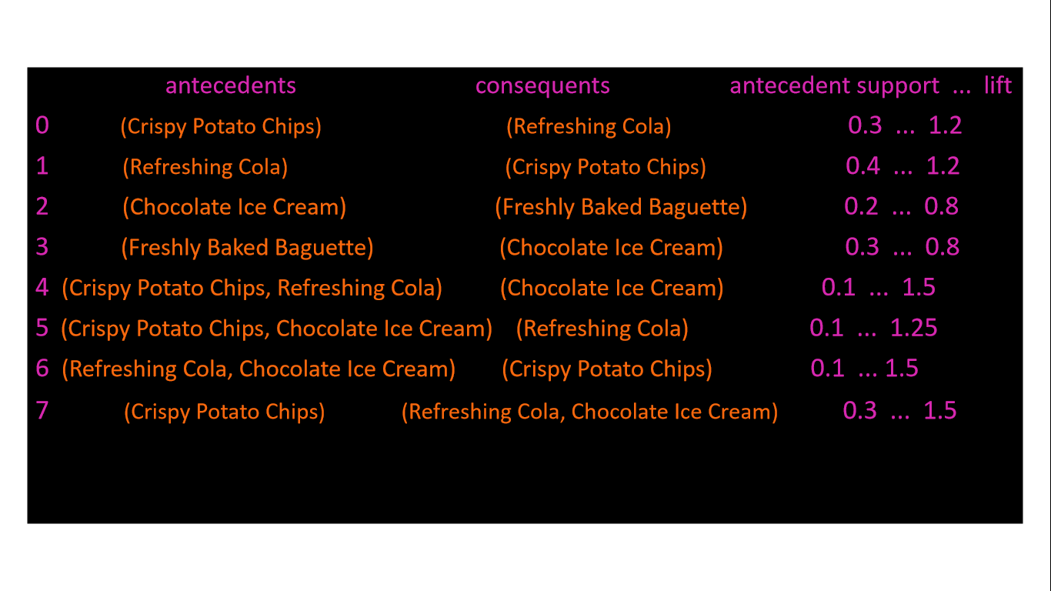

**CONCLUSION:**

Analyzing market basket data has yielded valuable insights into consumer behavior and shopping trends. Through the examination of customer purchase patterns, retailers and businesses can make informed decisions to enhance their marketing strategies and optimize product offerings.

One key observation is the power of product recommendations. By identifying frequently co-purchased items, retailers can create targeted recommendation systems that encourage customers to discover and purchase related products. This not only boosts sales but also enhances the overall shopping experience.

Furthermore, market basket analysis has shed light on seasonality and trends. Retailers can identify which products are popular during specific times of the year and adjust their inventory accordingly. For example, ice cream and sunscreen may see increased sales in the summer, while warm clothing items become more popular in the winter.

Another critical insight is the identification of cross-selling opportunities. Retailers can bundle complementary products together, encouraging customers to buy more than originally intended. For instance, pairing a gaming console with related accessories or offering a discount on a second item can increase average transaction values.

In conclusion, market basket insights are invaluable for retailers and businesses looking to thrive in today’s competitive marketplace. By harnessing the power of data analytics, businesses can enhance their customer experience, optimize inventory, boost sales, and make data-driven decisions that drive growth and success. In an era where data is king, market basket analysis stands as a pillar of informed decision-making for businesses of all sizes.